# Creating a Storage Account using PowerShell

## Lab Overview

In this lab you will install and configure the Azure PowerShell cmdlets. You will then create a storage account using PowerShell.

## Prerequisites

* Microsoft Azure Subscription: <http://azure.microsoft.com/en-us/pricing/free-trial/>

## Time Estimate

* 15 minutes

## Table of Contents

Creating a Storage Account 1

Lab Overview 1

Prerequisites 1

Time Estimate 1

Table of Contents 1

Exercise 1: Login to the Azure Management Portal 1

Exercise 2: Create a Storage Account 2

Lab Summary 5

## Exercise 1: Download and install the Azure PowerShell cmdlets.

1. Open your browser and navigate to <http://azure.microsoft.com>
2. Click Downloads and then click the Install link under Windows PowerShell.

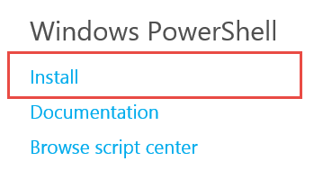

1. Click Run when prompted and follow the instructions to install the cmdlets.



## Exercise 2: Configure the Azure PowerShell cmdlets for your Subscription

1. Create a new shortcut on your desktop that links to Azure PowerShell.
2. Right click on the new shortcut and click Run as administrator.

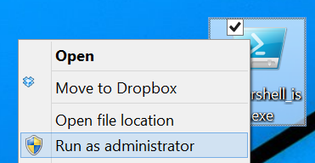

1. Execute the following command:

Add-AzureAccount

1. When prompted, enter the credentials for your subscription.

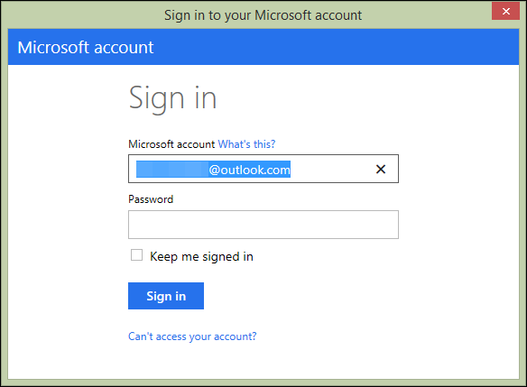

1. After signing in, you should see your subscription information.

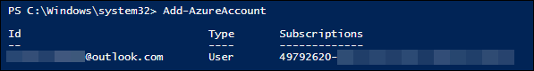

1. Execute the following command to see a list of your Azure subscriptions and their corresponding information. At this point, mine only shows one.

Get-AzureSubscription

1. For the subscription you want to use as your default, save the ID and Name. The name of the subscription here is “Azure Pass”.

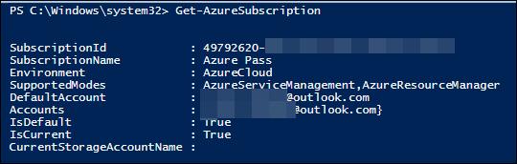

1. Now set the current and default Azure subscription to the one you want by executing these commands.

Select-AzureSubscription –SubscriptionName “Azure Pass” –Default

Select-AzureSubscription –SubscriptionName “Azure Pass” –Current

1. Now that you’re pointing to the right subscription, execute the following command to create a new storage account. Specify your own storage account name and location.

New-AzureStorageAccount –StorageAccountName “nameofnewaccount” –Location “West US”

If the storage account already exists, you will get an error message. If you were able to add the storage account successfully, you should see something like the following.



1. Now select that storage account as the default to go with the subscription. These defaults will be used the next time you run PowerShell.

Set-AzureSubscription –SubscriptionName “Azure Pass” –CurrentStorageAccountName “nameofnewaccount”

You can execute the following command to see the default subscription with its storage account name.

Get-AzureSubscription

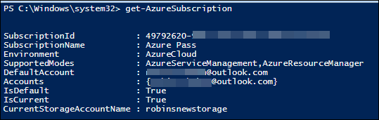

You are now set up to use this subscription and your new storage account for labs in the rest of this course. In this example, I set up a new storage account called “robinsnewstorage”.

## Lab Summary

In this lab you have set up the Azure Powershell cmdlets to work with your Azure subscription and created a storage account that can be used for the hands-on labs in this course.